Core Standards and Specifications Vocabulary (CSSV)
v.1.0.0
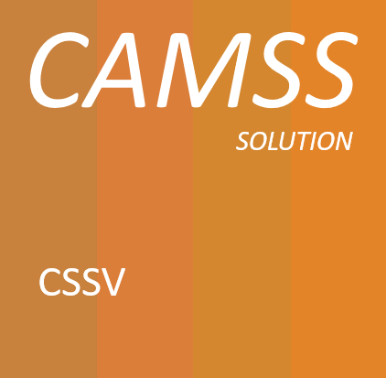
Specification

Change Control
Modification | Details
Version 1.0.0
Initial version

TABLE OF CONTENTS

1. Introduction 6
1.1. Context 6
1.2. The Problem Statement 6
1.3. Scope 7
1.4. Proposed solution 7
1.5. Structure of this document 7
2. Related Solutions 8
2.1. CAMSS Ontology 8
2.2. Core Assessment Vocabulary (CAV) 8
2.3. EIRA Library of Interoperability Specifications (ELIS) 9
2.4. DCAT-AP and ADMS-AP 9
3. CSSV Public Consultation 11
3.1. Promotion Activites 11
3.2. Issues Overview 14
3.3. Metrics 15
4. Core Standards and Specifications Vocabulary 16
4.1. Data Model for the CSSV 16
4.1.1. Interpretation 17
4.2. Class: Specification 19
4.2.1. Property: dct:identifier 19
4.2.2. Property: dct:title 20
4.2.3. Property: dct:alternative 20
4.2.4. Property: dct:description 20
4.2.5. Property: dct:abstract 21
4.2.6. Property: dct:type 21
4.2.7. Property: dct:creator 21
4.2.8. Property: cssv:configuredIn 22
4.2.9. Property: cssv:combinedIn 22
4.3. Class: cssv:Standard 23
4.4. Class: cssv:ApplicationProfile 23
4.4.1. Property: cssv:configures 23
4.5. Class: cssv:Family 24
4.5.1. Property: cssv:combines 24
4.6. Class: cssv:Scope 24
4.6.1. Property: cssv:ID 25
4.6.2. Property: cssv:Description 25
5. Findings and Conclusions 25
6. Conformance statement 26
7. Accessibility and Multilingual Aspects 27
8. Acronyms 27
9. References 28
10. Annex I - Public Consultation Report 28
11. Annex II – CSSV Public Consultation Documentation 28
12. Annex III – CSSV Model 28

Table of Figures
Figure 1: DCAT-AP classes and properties 10
Figure 2: ADMS-AP model 11
Figure 3 News of the CSSV Public Consultation 12
Figure 4 CSSV Public Consultation on Twitter 13
Figure 5 CSSV Public Consultation on LinkedIn 13
Figure 6 Total issues 14
Figure 7 Joinup metrics 15
Figure 8 GitHub metrics 15
Figure 9: CSSV Data model 17

Introduction
The CSSV is the vocabulary used for the information exchange related to standards and specifications amongst software solutions, as well as, it is the key element for the development of the new release of the EIRA Library of Interoperability Specifications (ELIS). In order to improve the quality of this vocabulary, it has been reviewed publicly through a public consultation where some stakeholders contributed to the improvement of the CSSV.

Context
The ISA2 Programme of the European Commission supports the development of solutions that enable the cross-border delivery of interoperable public services in Europe. In order to ensure the interoperability of those services, the EIA action works as an integrator between the Member States and other departments of the European Commission for the development of a joint interoperability architecture for public services. The main output of this action is the European Interoperability Reference Architecture (EIRA©).
As an element of EIRA©, the EIRA Library of Interoperability Specifications (ELIS) was created. The ELIS contains the specifications describing the interoperability requirements of the architecture building blocks (ABBs) that conform to EIRA©.
At the core of the ELIS, there is also another asset developed in the context of the CAMSS action that shall be referenced which has been further developed: the Core Standards and Specifications Vocabulary (CSSV).

The Problem Statement
The problem statement | At the present stage, there is not a clear definition of what a specification, a standard, a family of specifications and application profiles are. Similarly, it is not clearly expressed how the standards and specifications are related, and what are their purposes and constraints. Moreover discovering and cataloguing interoperability assets – such as EIRA building blocks— with standards and specifications that support their development is currently a hard and time-consuming task. This situation
affects | all European public administrations, citizens, among others, that need to use specifications or to make reference to them, for the description of specifications in order to facilitate their identification, use, cataloguing and exchange between systems (e.g. ELIS);
the impact of which is | that the building of electronic catalogues is hampered by problems during the discovery and cataloguing of specifications. This impacts the research of specifications in the catalogue and the users researching specifications. Ultimately, the difficulty in identifying and getting information about the specifications hinders its reuse, the possibility of assessing the conformance of the specifications to regulated purposes and frameworks (scenarios) and, therefore, to formally support other needs and developments.
A successful solution would be | to come up with a common vocabulary that is able to clearly define the main concepts related to standards and specifications.

Scope
The objective of this document is to provide an interoperability oriented solution for the information exchange related to standards and specifications amongst software solutions, the Core Standards and Specifications Vocabulary.
The CSSV specified in this document has been developed taking into account inputs from different sources, namely, the works developed for the ISA2’s CAMSS Action, interested MS, the Semantic Interoperability Community (SEMIC) action of the ISA2 Programme and IT consultants working for the European Commission.
In addition, this vocabulary has been analysed publicly with the objective to get a stable version of the vocabulary which will be used for the development of the new ELIS release. The Public Consultation of the CSSV started on the 24th of October and finalised on the 24th of November. During this period, some change requests have been received and integrated in the CSSV data model, see 4.1 Data Model for the CSSV.

Proposed solution
The CSSV defined in this document is based on a preliminary Core Interoperability Standards and Specifications Vocabulary (CISSV) and EIRA CISSV-AP model, which was used for the development of the BETA version of the ELIS in 2018. The CSSV thus replaces that other preliminary model.

Structure of this document
This document consists of the following sections:
- Section 2 describes the related solutions to the Core Standards and Specifications Vocabulary (CSSV).
- Section 3 contains the report of the Public Consultation of the CSSV.
- Section 4 explains the CSSV model and identifies the classes and properties defined for the vocabulary.
- Section 5 contains the Conformance Statement for this vocabulary.
- Section 6 describes specific accessibility and multilingualism aspects.
- Section 7 lists the different acronyms used in the whole document.
- Section 8 contains related references.

Related Solutions
This section lists the different related solutions to the CSSV. Note that some of them are still under development.

CAMSS Ontology
CAMSS stands for Common Assessment Method for Standards and Specifications and it is an action of the ISA2 Programme.
The CAMSS Ontology defines the CAMSS terminology and axioms that define the CAMSS concepts and logic rules. The interpretation of the CAMSS concepts cast a clear idea of the method defined in CAMSS to assess standards and specifications.
The CAMSS Ontology is currently under development.

Core Assessment Vocabulary (CAV)
The Core Assessment Vocabulary represents, expresses and defines what an “Assessment” of “Assets” is and how to perform the assessment based on “Criteria”. It is a domain-agnostic vocabulary, meaning that it can be used to assess any asset. Hence, the CAV is at the very core of the CAMSS Ontology. Or, in other words, the CAMSS Ontology reuses and extends the CAV.
The CAV is also under development. The current CAMSS tool, the CAMSS Ontology, the ELIS, and other projects under development are being used to test and refine the CAV.

EIRA Library of Interoperability Specifications (ELIS)
The ELIS is a family of interoperability specifications that define the interoperability aspects of the Architecture Building Blocks (ABBs) contained in EIRA©. Its aim is supporting architects for the modelling of solutions based on EIRA©. The current version of ELIS will have to be slightly revamped to accommodate the concepts defined in the CSSV and support the requirement of all the stakeholders, e.g. EIRA-based solution developer needs, NATO profiles, other.
The CSSV is based on the CISSV model, which was used for the development of the BETA version of the ELIS in 2018.

DCAT-AP and ADMS-AP
The DCAT Application profile for data portals in Europe (DCAT-AP) is a specification based on W3C's Data Catalogue vocabulary (DCAT) for describing public sector datasets in Europe. The Asset Description Metadata Schema (ADMS) in turn was developed as an application profile of the DCAT vocabulary for the description of assets. Hence, DCAT-AP can be used to describe any type of asset (treated as a dataset, especially if you consider that metadata are also data).
The figure below shows the DCAT-AP classes and properties:
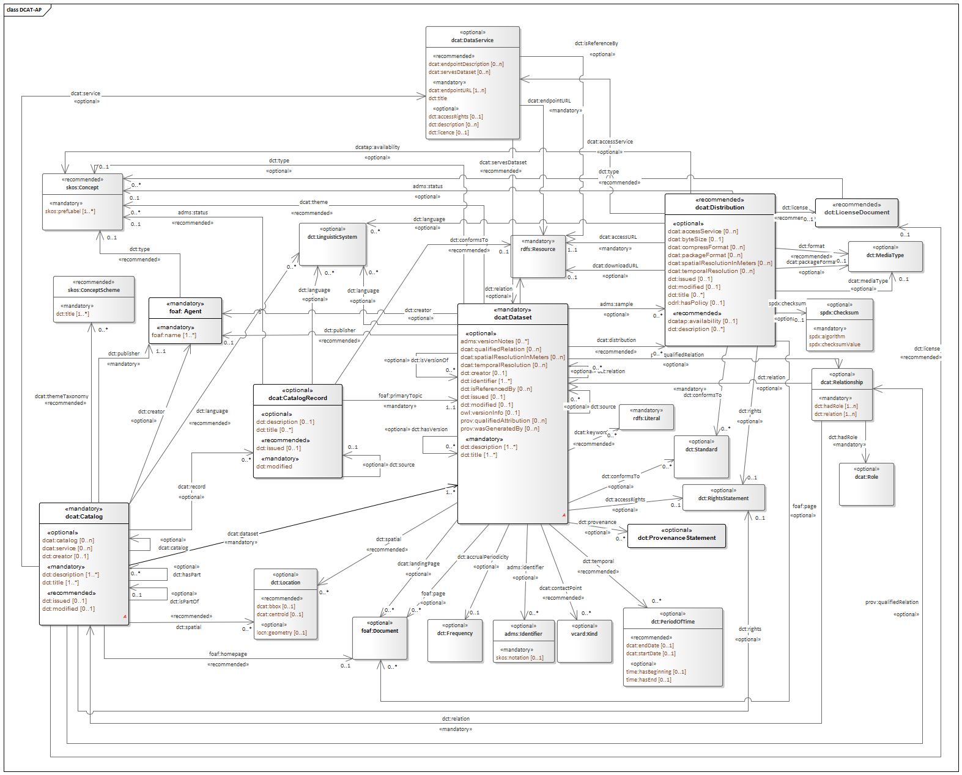
Figure 1: DCAT-AP classes and properties
In the CSSV model, the class Specification can be considered the “root” class and it is an “Asset” as defined in ADMS, which in turn inherits from the dcat:Dataset class. The figure below shows how ADMS defines the concept Asset, based on DCAT:

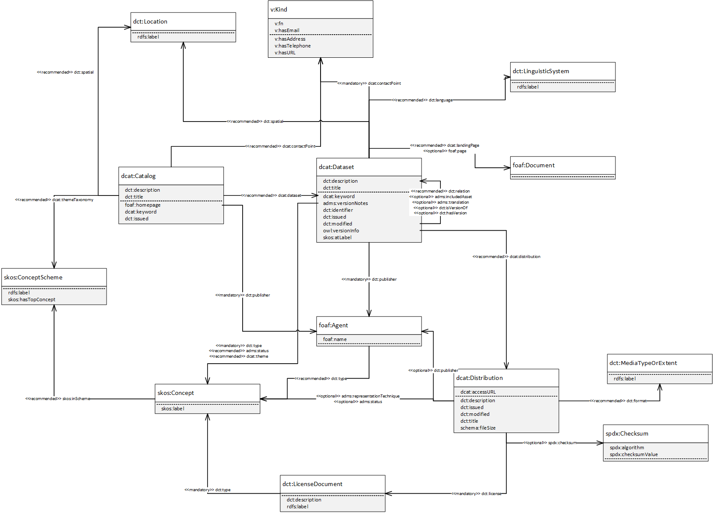
Figure 2: ADMS-AP model

CSSV Public Consultation
The Public Consultation prepared for the open analysis of the CSSV was carried out through the SEMIC GitHub platform where a repository for the CSSV was created. There, the interested stakeholders submitted their comments creating issues. The Public Consultation started on the 24th of October and finalised on the 24th of November.

Promotion Activites
The participation of different stakeholders around Europe that could contribute to the improvement of the new vocabulary was one of the main objectives of the Public Consultation. For this purpose, some promotion activities were performed in order to ensure the maximum possible involvement of contributors:
- News in Joinup Communities:
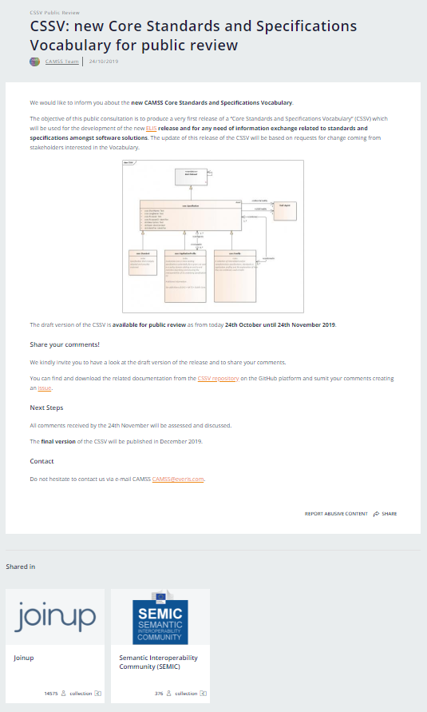
Figure 3 News of the CSSV Public Consultation
- ISA2 social media Channels:
- Twitter: https://twitter.com/EU_ISA2/status/1193933060976320518
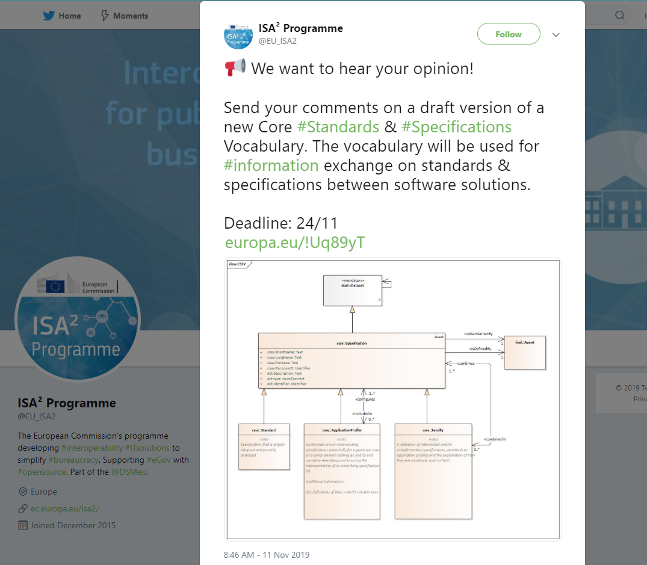
Figure 4 CSSV Public Consultation on Twitter
- LinkedIn: https://www.linkedin.com/posts/isa2programme_interoperability-standards-specifications-activity-6599699860394393600-IyHh
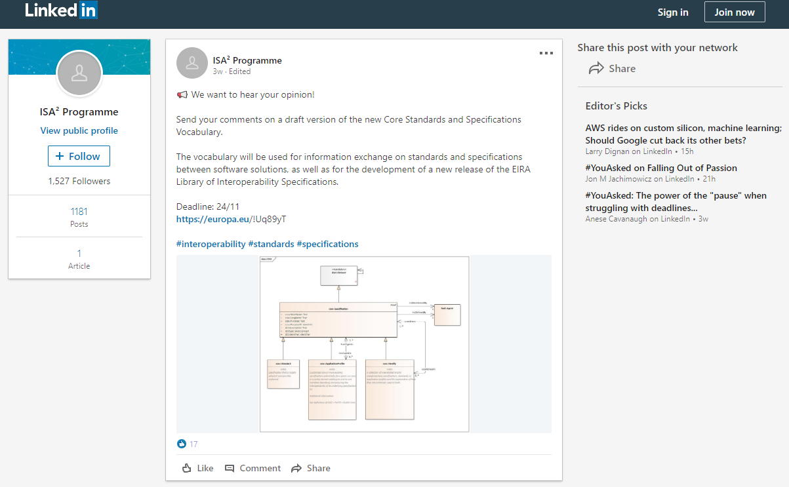
Figure 5 CSSV Public Consultation on LinkedIn
- Other promotion activities:
Additionally to the promotion activities explained above, the CAMSS team informed the experts in charge of the review of the CAMSS Ontology about the CSSV Public Consultation. As well as, the CAMSS Team was in contact with different SDOs (OASIS, W3C representative members, and MSP) where the CSSV consultation was promoted. The comments received have been tracked and they will be analysed during the update of the vocabulary. The comments received from the experts can be consulted in Annex I - Public Consultation Report.

Issues Overview
A total of 8 issues were received over the 4 weeks consultation period. The picture below shows the issues created in GitHub:
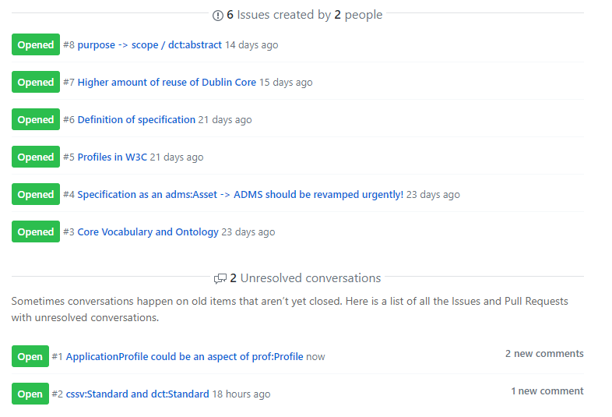
Figure 6 Total issues
These issues have been treated and commented accordingly. These issues have been treated and commented accordingly. The issues received with the CAMSS Teams' replies can be consulted in Annex I - Public Consultation Report.

Metrics
This section provides the metrics of the Public Consultation in Joinup and GitHub.
- Joinup:
MONTH | PAGE URL | PAGEVIEWS | UNIQUE PAGEVIEWS | BOUNCE RATE | AVG. TIME ON PAGE
Oct-19 | collection/common-assessment-method-standards-and-specifications-camss/news/cssv-public-review | 37 | 23 | 60% | 0:00:54
Nov-19 |  | 79 | 50 | 42.5% | 0:01:50
Figure 7 Joinup metrics
- GitHub:
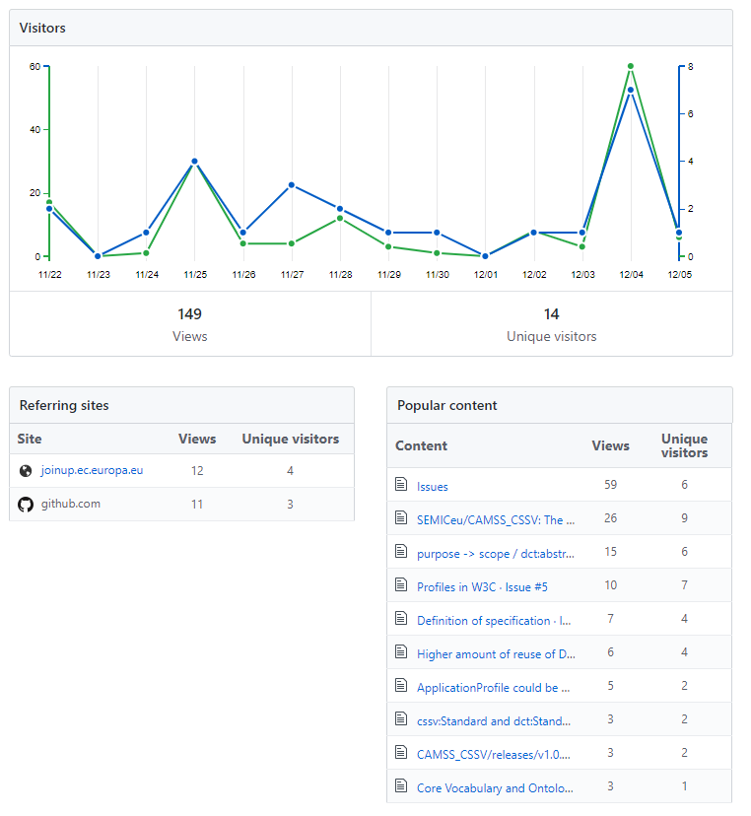
Figure 8 GitHub metrics

Core Standards and Specifications Vocabulary
The Core Standards and Specifications Vocabulary is depicted in Figure 3 CSSV Data model. The figure shows the classes and properties that are used or defined in the CSSV.

Data Model for the CSSV
The following data model results from:
- The analysis performed by the CAMSS Team,
- A peer review conducted by a group of five experts working for the European Commission,
- The comments issued by the open community in the public GitHub set up for this public consultation,
- The comments issued by European and international relevant stakeholders, e.g. the MSP and known SDOs11, 12, 13.
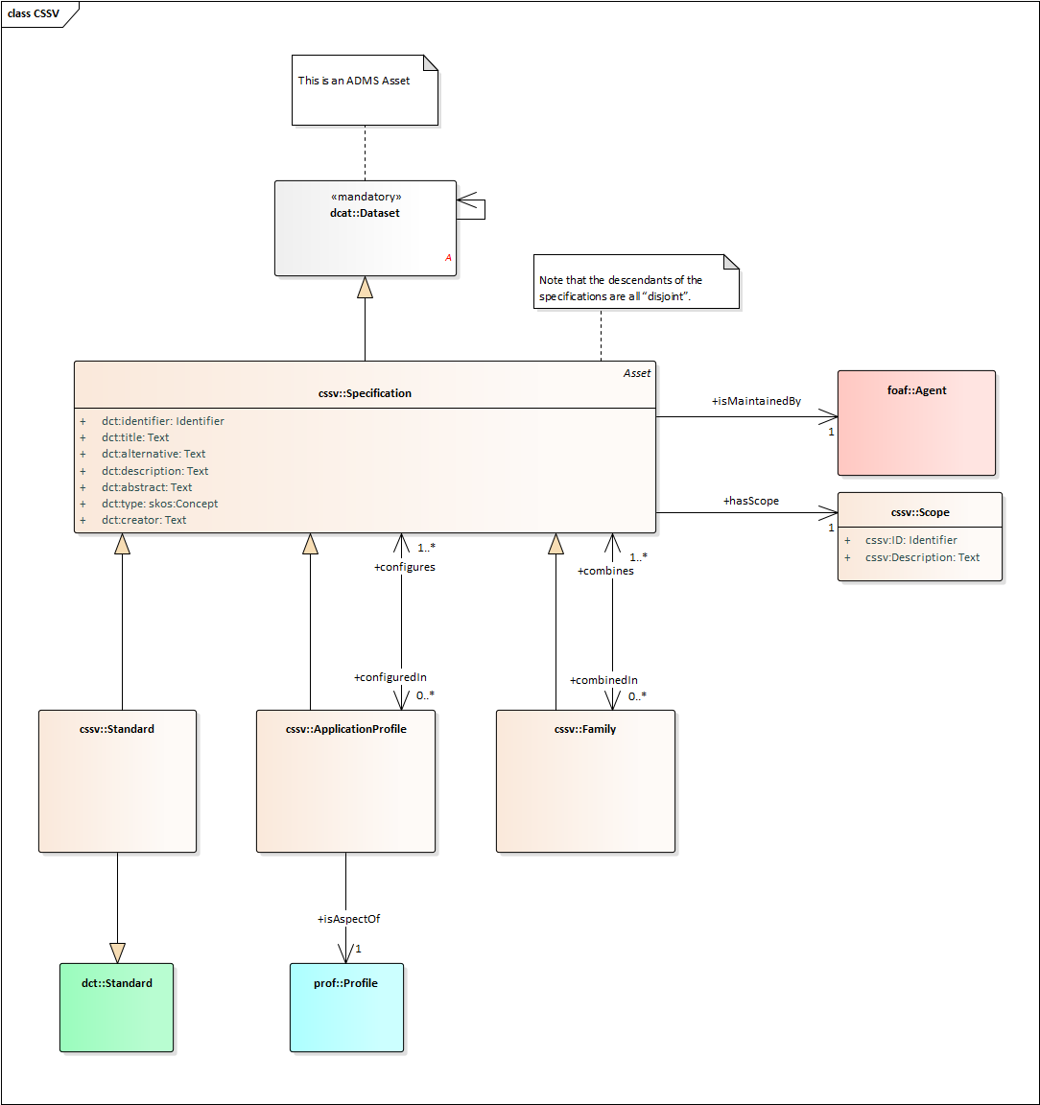
Figure 9: CSSV Data model

Interpretation
The main class of the CSSV model is the “Specification”. A Specification is an asset, as it inherits from the dcat:Dataset, which is the representative of an ADMS Asset.
A Specification, additionally, can be a Standard, an ApplicationProfile and or a Family or a collection of other specifications. The CSSV model defines:
- A Specification as a set of agreed, descriptive and normative statements about how a specification should be designed or made.
- A Standard as a specification that is largely adopted and possibly endorsed.
- An ApplicationProfile as customisation of one or more existing specifications potentially for a given use case or a policy domain adding an end-to-end narrative describing and ensuring the interoperability of its underlying specification(s). By customisation, we understand the “addition of more specificity by identifying mandatory, recommended and optional elements, as well as by defining controlled vocabularies to be employed”.
- A Family as a collection of interrelated and/or complementary specifications, standards or application profiles and the explanation of how they are combined, used or both.
A collection of Specifications differs from a Family of Specifications in the fact that the relationship amongst themselves is not explicit. In the CSSV model, a collection of Specifications is an Asset that is related to other Assets and that is realised as an individual of a Specification. In other words, a Specification that reuses the dct:relation property of its base class dcat:Dataset.
There are occasions where collections of Specifications are applied to a context or a domain in a specific “configuration”. Thus application profiles may conform sets of “themed” specifications. For this, the CSSV model uses the property “configures/includedIn” and the dcat:theme property pointing at a skos:Concept (i.e. a code, see the DCAT model above).
It is important to note that the descendants of the specifications are all “disjoint”. Thus, ApplicationProfiles and Families are Specifications that refer to or put together with other Specifications and/or Standards, but cannot themselves be considered Standards.
One Specification, in time, may become a Standard. In these cases, the authority (author) that defined the Specification may be different from the one that creates and maintains artefacts out of the Standard. Think for example of the artefacts produced, maintained and distributed by the Publications Office of the European Union (OP) in its site EU Vocabularies: all these artefacts are defined by other authorities (e.g. the ISO), whilst the artefacts (e.g. the controlled vocabularies expressed in SKOS, XML, GeneriCode, XML, etc.) are supplied by the OP. For this, the CSSV uses the properties dct:creator and cssv:isMaintainedBy. Additionally, the dcat:Dataset has the property dct:type that can be used to state that the Specification is of type “definition, artefact or other”. The DCAT vocabulary also provides the possibility of expressing who is responsible for the publication of the definition or the artefacts via the property dct:publisher (see the ADMS and DCAT models).
The maintainer or publisher of a Specification is a foaf:Agent, which allows great flexibility to the CSSV model as foaf:Agent is the base class in many ontologies. The CSSV puts forward the reuse of the Core Person Vocabulary (ISA2 CPV) and the Organization Ontology (W3C Org) for this purpose.
In terms of reusability, the class cssv:Scope allows the reuse of the Specification. It makes reference to the area of requirements addressed by the specification.
Finally, note that all the descendants of the ccsv:Specification are disjoint. This entails that an individual of an application profile or family cannot be a standard, but does not preclude that, in time, the application profile or the family can become standards. If that were the case then individuals of ccsv:Standard would be created to represent the standardisation of those specifications that are application profiles and families.

Class: Specification
OWL Class | cssv:Specification
Label: | Specification
Definition: | Set of agreed, descriptive and normative statements about how a specification should be designed or made.
Subclass of: | dcat:Dataset
The sections below list the data properties (class attributes) inherited from ADMS that are of particular interest to the class Specification:

Property: dct:identifier
OWL Property | dct:identifier
OWL type: | owl:DataProperty
Label: | identifier
Definition: | This property contains the main identifier for the specification, e.g. the URI or another unique identifier.
Property Type: | xsd:AnyURI
Examples: | Any URI pointing at an instance of an Asset. An example of this could be:  - DCAT (W3C)  - URI: http://www.w3.org/ns/dcat#  - Expression in CSSV:  @prefix cssv: <http://data.europa.eu/xyz/cssv#> .  @prefix dct: <http://purl.org/dc/terms/> .  <http://www.w3.org/ns/dcat#>  a <cssv:Specification> ;  dct:identifier ”http://www.w3.org/ns/dcat#” .

Property: dct:title
OWL Property | dct:title
OWL type: | owl:DataProperty
Label: | Title
Definition: | The name given to the Specification.
Property Type: | xsd:String
Examples: | Core Standards and Specifications Vocabulary, Core Assessment Vocabulary, Core Public Service Vocabulary, Core Criterion and Core Evidence Vocabulary, etc.

Property: dct:alternative
OWL Property | dct:alternative
OWL type: | owl:DataProperty
Label: | Alternative Title
Definition: | The alternative name of the specification.
Property Type: | xsd:String
Examples: | CSSV, CAV, CPSV, CCCEV, etc.

Property: dct:description
OWL Property | dct:description
OWL type: | owl:DataProperty
Label: | description
Definition: | This property contains a free-text account of the Specification. This property can be repeated for parallel language versions of the description.
Property Type: | xsd:String
Examples: | A free-text account of the Specification.

Property: dct:abstract
OWL Property | dct:abstract
OWL type: | owl:DataProperty
Label: | Abstract
Definition: | A summary of the specification.
Property Type: | xsd:String
Examples: | To define the main concepts and characteristics related to specifications, standards and their combinations and relationships.

Property: dct:type
OWL Property | dct:type
OWL type: | owl:DataProperty
Label: | type
Definition: | This property refers to the type of the Specification. A controlled vocabulary for the values has not been defined for the time being. A proposal is provided in the examples below.
Property Type: | skos:Concept
Examples: | Definition, Artefact, Summary.

Property: dct:creator
OWL Property | dct:creator
OWL type: | owl:DataProperty
Label: | Creator
Definition: | The entity primarily responsible for making the specification.
Property Type: | xsd:AnyURI
Examples: | A creator include a person, an organization, or a service.

Property: cssv:configuredIn
OWL Property | cssv:configuredIn
OWL type: | owl:ObjectProperty
Label: | configuredIn
Definition: | A set of Specifications potentially for a given use case or policy domain that are aggregated in an ApplicationProfile.
Domain: | cssv:Specification
Range: | cssv:ApplicationProfile
Examples: | Instance classes representing application profiles, such as DCAT-AP, ADMS-AP, other.

Property: cssv:combinedIn
OWL Property | cssv:combinedIn
OWL type: | owl:ObjectProperty
Label: | combinedIn
Definition: | A set of Specifications that are complementary and interrelated, forming a Family of Specifications.
Domain: | cssv:Specification
Range: | cssv:Family
Examples: | OASIS UBL XML-based family (XML, XML Schema Definition, ISO Schematron, OASIS Genericode, Context Value Association (CVA), UN/CEFACT unqualified data types); OASIS JSON-based family; CEN TC 440 families; UN/CEFACT CII eInvoice family; other.

Class: cssv:Standard
OWL Class | cssv:Standard
Label: | Standard
Definition: | Specification that is largely adopted and possibly endorsed.
Subclass of: | cssv:Specification
At the present stage all the properties of the cssv:Standard class are the ones inherited from cssv:Specification and dcat:Data set.

Class: cssv:ApplicationProfile
OWL Class | cssv:ApplicationProfile
Label: | Application Profile
Definition: | An application profile “customises one or more existing specifications potentially for a given use case or a policy domain adding an end to end narrative describing and ensuring the interoperability of its underlying specification(s)”.
Subclass of: | cssv:Specification

Property: cssv:configures
OWL Property | cssv:configures
OWL type: | owl:ObjectProperty
Label: | Configures
Definition: | Whether an Application Profile design or adapts a Specification for a specific purpose.
Domain: | cssv:ApplicationProfile
Range: | cssv:Specification
Examples: | DCAT-AP configuring DCAT for its use in the context of the EU Public Administrations; Any NATO profile configuring a set of interoperability Specifications for a specific context of use; other.

Class: cssv:Family
OWL Class | cssv:Family
Label: | Family
Definition: | A family is a collection of interrelated and/or complementary specifications, standards or application profiles and the explanation of how they are combined, used or both.
Subclass of: | cssv:Specification

Property: cssv:combines
OWL Property | cssv:combines
OWL type: | owl:ObjectProperty
Label: | Combines
Definition: | Whether a Family is a union of more than one Specifications.
Domain: | cssv:Family
Range: | cssv:Specification
Examples: | One or more Specifications that are part of a family, e.g. OASIS UBL XML-based family (XML, XML Schema Definition, ISO Schematron, OASIS Genericode, Context Value Association (CVA), UN/CEFACT unqualified data types); OASIS JSON-based family; CEN TC 440 families; UN/CEFACT CII eInvoice family; other. Conformance Statement.

Class: cssv:Scope
OWL Class | cssv:Scope
Label: | Scope
Definition: | Area of requirements addressed by the specification.

Property: cssv:ID
OWL Property | cssv:ID
OWL type: | owl:DataProperty
Label: | identifier
Definition: | This property contains the main identifier for the scope, e.g. the URI or another unique identifier.
Property Type: | xsd:AnyURI
Examples: | Any URI pointing at an instance of the Scope.

Property: cssv:Description
OWL Property | cssv:Description
OWL type: | owl:DataProperty
Label: | description
Definition: | This property contains a free-text account of the Scope. This property can be repeated for parallel language versions of the description.
Property Type: | xsd:String
Examples: | A free-text account of the Scope.

Findings and Conclusions
The public consultation has produced some findings and relevant conclusions:
- Finding #1: a data model, vocabulary or ontology tackling the domain of standards and specifications was not found. However two recent initiatives are to be mentioned:
  - NISO recently voted a new project to create a Standards-Specific Ontology Standard (short title: NISO SSOS). A working group is in the process of being formed to develop and standardize a high-level ontology to describe a limited set of core concepts and relationships.
  - W3C has developed “The Profiles Vocabulary”, an RDF vocabulary to describe profiles of (one or more) standards for information resources. It describes the general pattern of narrowing the scope of a specification with additional, but consistent, constraints, and is particularly relevant to data exchange situations where conformance to such profiles is expected and carries additional context.
- Conclusion related to Finding #1: The CAMSS CSSV development team should contact these two initiatives and examine how synergies and collaboration could be established from now on. Additionally the CAMSS Team should invite them to participate actively in the evolution of the CSSV via the governance and maintenance mechanisms put forward by ISA2.
- Finding #2: The CAMSS Teams and the ISA2 Communications Team performed a proper dissemination of the public consultation. However the feedback provided by the community and contacted stakeholders has produced very few feed-back with no major impacts on the proposed data model.
- Conclusion related to Finding #2: The community has not have the opportunity of applying the model to actual Use Cases and the comments received are based on the reading of the conceptual model and its related documentation. Proof of concepts and pilots should be proposed for multiple different business and problem domains in order to challenge the vocabulary.

Conformance statement
A data interchange of Standards or Specifications, however that interchange occurs, is conformant with the CSSV if:
- it uses the terms (classes and properties) in a way consistent with their semantics as declared in this specification;
- it does not use terms from other vocabularies instead of ones defined in this vocabulary that could reasonably be used.
A conforming data interchange:
- may include terms from other vocabularies;
- may use only a subset of CSSV terms.
The CSSV is technology-neutral and a publisher may use any of the terms defined in this document encoded in any technology although RDF and XML are preferred.

Accessibility and Multilingual Aspects
The CSSV can operate in any language as:
- In a multilingual context, all those properties that are datatype “Text” the value may exist in multiple languages, the property may be instantiated multiple times and tagged with the language identifier for the value used for that property.
- The CSSV specification encourages the use of PURIs as identifiers.
The labels used can be translated and added to the schema (please contact the working group if you can help with this).

Acronyms
Term | Description
EIRA© | European Interoperability Reference Architecture
ELIS | EIRA Library of Interoperability Specifications
ABBs | Architecture Building Blocks
CSSV | Core Standards and Specifications Vocabulary
SEMIC | Semantic Interoperability Community
CISSV | Core Interoperability Standards and Specifications Vocabulary
EIRA CISSV-AP | EIRA Core Interoperability Standards and Specifications Vocabulary Application Profile
CAV | Core Assessment Vocabulary
DCAT | Data Catalogue Vocabulary
DCAT-AP | Data Catalogue Vocabulary Application Profile
ADMS | The Asset Description Metadata Schema
CPSV | Core Public Service Vocabulary

References
ADMS . (n.d.). Retrieved from https://joinup.ec.europa.eu/collection/semantic-interoperability-community-semic/adms
CAMSS - Common Assessment Method for Standards and Specifications. (n.d.). Retrieved from https://joinup.ec.europa.eu/collection/common-assessment-method-standards-and-specifications-camss/about
DCAT-AP v1.1. . (n.d.). Retrieved from https://joinup.ec.europa.eu/release/dcat-ap-v11
EIRA - European Interoperability Reference Architecture. (n.d.). Retrieved from https://joinup.ec.europa.eu/collection/european-interoperability-reference-architecture-eira/about
ELIS - EIRA Library of Interoperability Specifications. (n.d.). Retrieved from https://joinup.ec.europa.eu/release/eira-library-interoperability-specifications-elis/v100-beta
ESCO Taxonomy. (n.d.). Retrieved from https://ec.europa.eu/esco/portal/occupation
EU Vocabularies. (n.d.). Retrieved from https://publications.europa.eu/en/web/eu-vocabularies/controlled-vocabularies
W3C. (2019, October 03). Retrieved from Data Catalog Vocabulary (DCAT): https://www.w3.org/TR/vocab-dcat/

Annex I - Public Consultation Report

Annex II – CSSV Public Consultation Documentation
https://github.com/SEMICeu/CAMSS_CSSV/tree/master/releases/v1.0.0

Annex III – CSSV Model

CSSV Public Consultation: https://github.com/SEMICeu/CAMSS_CSSV
EIRA: https://joinup.ec.europa.eu/collection/european-interoperability-reference-architecture-eira/about
ELIS: https://joinup.ec.europa.eu/release/eira-library-interoperability-specifications-elis/v100-beta
CAMSS: https://joinup.ec.europa.eu/collection/common-assessment-method-standards-and-specifications-camss/about
Achieving a modern standard ICT standardisation policy; CAMSS Action 2016.27: https://ec.europa.eu/isa2/actions/achieving-modern-ict-standardisation-policy_en.
DCAT-AP: https://joinup.ec.europa.eu/solution/dcat-application-profile-data-portals-europe/release/200
W3C DCAT specification: https://www.w3.org/TR/vocab-dcat/
ADMS: https://joinup.ec.europa.eu/collection/semantic-interoperability-community-semic/adms
GitHub of SEMIC: https://github.com/SEMICeu
OASIS Webpage: https://www.oasis-open.org/
W3C Webpage: https://www.w3.org/
European Multi Stakeholder Platform on ICT Standardisation: https://ec.europa.eu/digital-single-market/en/european-multi-stakeholder-platform-ict-standardisation
CSSV Public Consultation issues: https://github.com/SEMICeu/CAMSS_CSSV/issues
EU Vocabularies: https://publications.europa.eu/en/web/eu-vocabularies/controlled-vocabularies
NISO-SSOS: https://www.niso.org/niso-io/2019/11/wgc-new#ssos.

